Academic Tutoring Record
Year 12 Formal Meeting 1/4
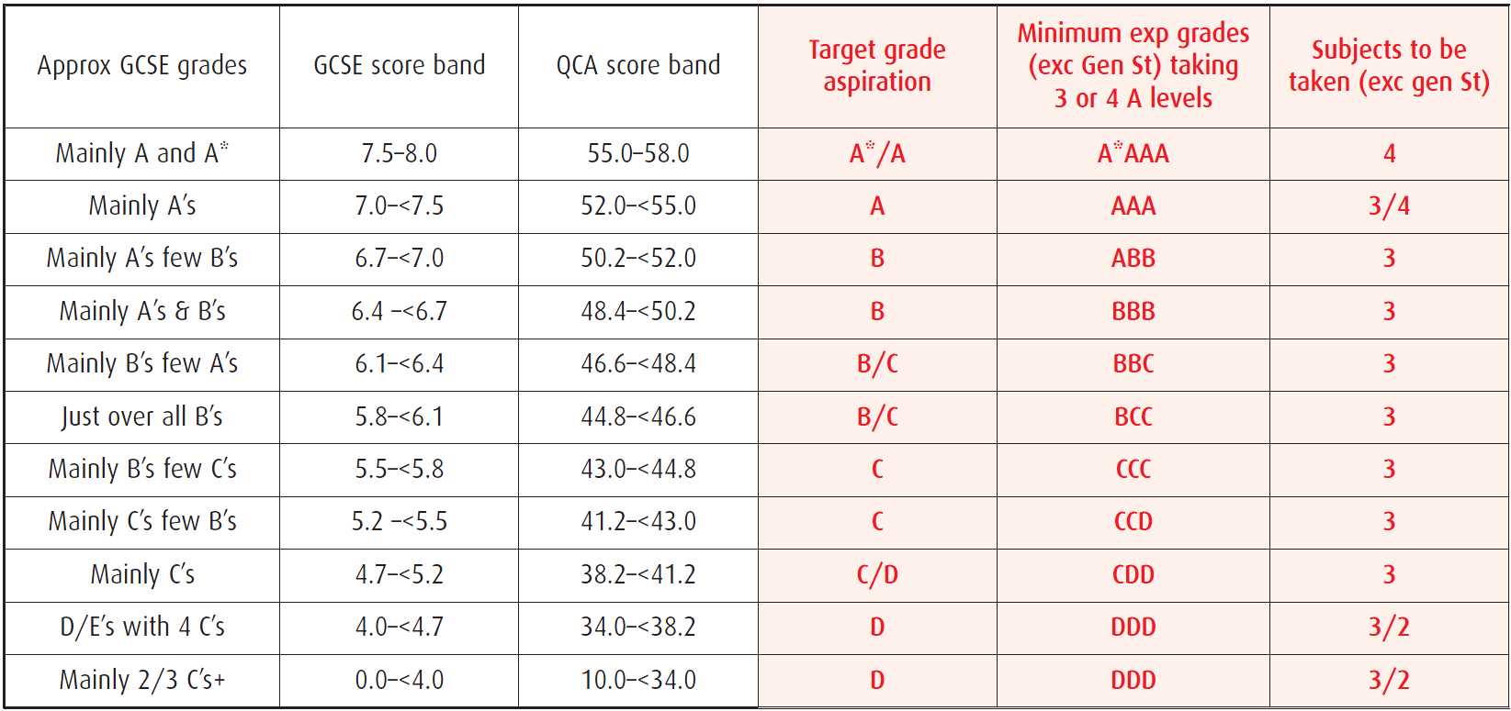
Aim: To know my MEGs, understand where they come from and reflect on how I can adjust most effectively to Sixth Form life.
My GCSE Points Score:_______________________
These grades are those which are achieved on average by the top 25% of students whose GCSE points scores matches yours. You are aiming to be in that top 25%.
As a whole our 6th form is in the top 25%.
Subjects | Expected Grade
1

2

3

4

Challenges and Strategies
- How satisfied are you with your current study habits and skills?

- Where are there any issues that I can support you with?

- What targets shall we set for you to achieve before we meet next?
Year 12 Formal Meeting 2/4- Interim Monitoring 1
Aim: To know the grade you are currently working at, to understand how your grades reflect your expected progress and to consider ways in which to challenge yourself to improve.

RED subjects hit target or better
Black subjects 1 grade below target
BLUE subjects 2 or more grades below target
RED NAMES all targets achieved
Subjects | Expected Grade | IM 1 Grade | Red/Grey/Blue
1

2

3

4

- Are you satisfied with your attainment and progress so far?

- Is your motivation and confidence (a) high (b) OK (c) poor?

- Are you satisfied with your current study habits and skills?

- What difficulties have you experienced so far?

- What difficulties have you overcome?

- How far have you achieved your target and what will your next be?
Year 12 Formal Meeting 3/4- Post Mock Review
Aim: To know the grade you are currently working at, to understand how your grades reflect your expected progress and to consider ways in which to challenge yourself to improve.
RED subjects hit target or better
Black subjects 1 grade below target
BLUE subjects 2 or more grades below target
RED NAMES all targets achieved

Subjects | Expected Grade | IM 1 Grade | Mock Grade | Green/Orange/Red
1

2

3

4

- How do your mock exam grades compare to your first IM grades?

- How far did your preparation reflect that which you expect it to in June?

- What did you find most challenging about these exams?

- How did you overcome them?

- Are you happy with your current study habits and skills?

- What targets shall we set for you to achieve before we meet next?

Year 12 Formal Meeting 4/4- IM 3; Pre Exam Reflection
Aim: To know the grade you are currently working at, to understand how your grades reflect your expected progress and to consider ways in which to challenge yourself to improve.

RED subjects hit target or better
Black subjects 1 grade below target
BLUE subjects 2 or more grades below target
RED NAMES all targets achieved

Subjects | Expected Grade | IM 1 Grade | Red/Grey/Blue
1

2

3

4

- How do your IM3 grades compare to your Mock exam and first IM grades?

- Have you obtained all of the necessary resources for your revision? If not what do you need?

- Are you happy with your study habits and revision strategies so far?

- Do you make effective use of your study time?

- Are you happy with your current study habits and skills?

